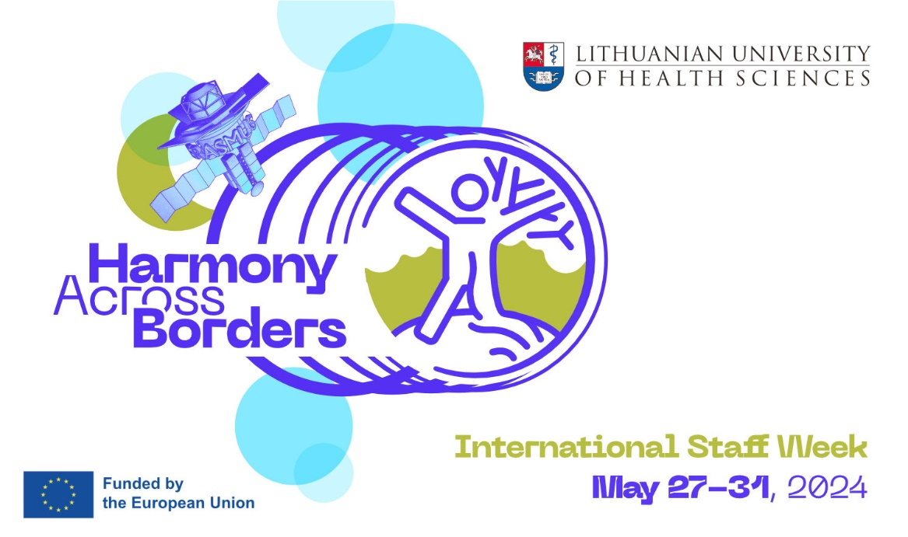

Provisional Programme

Day 1
Morning: Welcome to LSMU (presentations, facts, discussions, workshops)
Afternoon: Get Together Dinner

Day 2
Morning: LSMU guided Campus Tour - Simulation, Innovation, Research & Clinical Practice integrated
Afternoon: Teaching or Training activities at LSMU (lectures, workshops, networking)

Day 3
Morning: Teaching or Training activities at LSMU (lectures, workshops, networking)
Afternoon: Acquaintance with Local Cuisine (cultural workshop)

Day 4
Morning: Teaching or Training activities at LSMU (lectures, workshops, networking)
Afternoon: Explore Kaunas (guided tour)

Day 5
Morning: Lithuanian Tradition at a Glance (outbound excursion with lunch)
Afternoon: Certificates & Goodbyes

